Plaintiffs’ Mediation Brief

Jane Doe, et al. v. Roe Defendant, et al.
San Francisco Superior Court Case No.

Mediator: Honorable
Mediation:
Time:

Introduction
On [Date], John Doe, husband to Jane Doe and father to a minor daughter and son, was struck and crushed by a big rig tractor–trailer while crossing an intersection in San Francisco. At the time he was struck, John was within the marked crosswalk and traveling with a green light.
The trailer portion of the big rig was owned by Roe Defendant and was being hauled pursuant to a subhauler agreement by its agent, Roe Driver, the owner and operator of the tractor portion of the rig. The accident was caused by Roe Driver’s inattentiveness and failure to yield the right-of-way. John Doe suffered extensive injuries to his legs and lower torso and was transported to San Francisco General Hospital, where trauma surgeons attempted to repair the damage. Their efforts were futile; John Doe’s injuries were too severe. He died on the operating table. The remnants of the Doe family are pursuing a wrongful death action against Roe Defendant Trucking and Roe Driver, based on theories of general negligence on the part of Roe Driver, and Roe Defendant’s vicarious liability for the same based on its nondelegable duty as a trucking company.

Parties

Plaintiffs Doe
Jane Doe is John Doe’s widow. She and John married in 1986 and had celebrated their fifteenth wedding anniversary less than a week before the tragic accident. John and Jane had two children: a daughter, born in 1988, and a son, born in 1995. Each is a plaintiff in this action.
Before John Doe’s untimely death, the Does were an extremely close, tightly knit family unit. Supplied with this Mediation Brief is a video disk which includes examples of the type of evidence which will be presented to a jury as reflective of the relationship each member of the family enjoyed with John Doe and of the relationship of the family unit. As you will see, John Doe was devoted to his family. His daughter was thirteen when her dad was killed. Prior to his death, John Doe attended and supported his daughter’s school activities and helped her with algebra. He went to all her soccer games on Saturdays, and spent time with her going to the movies and shopping. His son was six when he lost his dad, whom he adored. John Doe would take his son to the park and on errands, play computer games with him, help him with his homework, and read to him on a nightly basis. An avid baseball fan, John Doe taught his son how to play and often took both of the children to see the Giants play. John Doe’s death has affected the individual relationships he shared with his wife and children, and has also affected the family unit as a whole.

Defendant Roe Driver
Roe Driver is a professional truck driver and was the owner-operator of the tractor portion of the big rig that struck and killed John Doe. At the time of the accident, Roe Driver was operating his truck driving business as a sole proprietorship. Roe Driver carries a commercial auto policy of insurance through Scottsdale Insurance Company with policy limits of $750,000. Defendant Roe Defendant is an additional insured under the policy.

Defendant Roe Defendant
Roe Defendant is a trucking company using the California public highways for profit, initially under the auspices of the Public Utilities Commission, and later, the Department of Motor Vehicles. Roe Defendant admits that it is engaged in a business giving rise to a great risk of harm to the public if it is not operated safely. Roe Defendant owns the trailer portion of the rig that struck and killed John Doe. On the date of the accident, Roe Defendant had engaged Roe Driver to transport materials from the Ryan landfill to San Francisco pursuant to a subhauler agreement. Roe Defendant carries a general commercial policy of insurance through ZC Insurance Company with policy limits of $1,000,000. Roe Defendant is also an additional insured under Roe Driver’s $750,000 policy, for a total policy limits of $1,750,000 available to resolve this case.

Facts
A. Background

John Doe was born in San Francisco, California. Raised in the Bay Area, John Doe graduated from Skyline High School in Oakland. He attended San Francisco State University and Merritt College, transferred to Chico State University, and graduated in 1971 with a bachelor’s degree in business administration. He later took graduate courses in communication at San Diego State University and ultimately attended and graduated from St. Mary’s College as a certified paralegal. At the time he was killed, John Doe was working as a paralegal. Before this, he had worked in the advertising field as a copywriter and salesperson.

In 1982, John Doe met Jane. Jane was immediately taken by John Doe’s sense of humor and joie de vivre, and they began dating shortly thereafter. John Doe showed her around the Bay Area, and the couple took short trips to the wine country.

Jane recalls being touched by John Doe’s thoughtfulness. At the time, she was working long hours, did not have time to do laundry, and admits her closets were “horrific.” One night she returned from work to discover the John Doe had done the laundry and organized her closets. Not surprisingly, Jane moved in with John Doe before a year was out. In 1985, they purchased a home together in San Jose, which they worked on together to improve. Four years after they met, they were married.

Shortly after they married, the Does decided to have children. A daughter was born in 1988. In 1993, the Does moved into a larger home, also in San Jose, which they also worked together on to improve. A son arrived in 1995.

In 1997, John Doe’s father died of liver cancer. The Doe family relocated to Oakland, moving into a home that needed substantial repairs and upgrading. As Jane and John Doe had done with other homes, they work to improve the Oakland house. They installed a whole new interior staircase, sank another pier in for the foundation, replaced all appliances, a heater, and a hot water heater, fixed the plumbing, and re-sided and painted the house.

At about the same time, a San Francisco attorney was handling the contested conservatorship of John Doe’s aunt. John Doe, with the attorney’s help, was providing legal and moral support to his father’s sister, who suffered from Alzheimer’s disease. The attorney later shared his thoughts on the quality of John Doe’s work: “John Doe was diligent, professional, and his work product was extremely high in quality.” (Exhibit 1, p. 1.)

John Doe enjoyed doing research and working on his aunt’s conservatorship. In doing so, he discovered that he an aptitude for and the desire to enter the legal field and witnesses will testify that, for John Doe, helping people made him “ feel great doing the right thing.” After discussing it with Jane, he decided that the best course of action was to return to school and obtain his paralegal certificate, then obtain employment at a law firm to build up his skills and expertise before tackling law school. John Doe attended the paralegal school at St. Mary’s College, where he was a standout student, graduating second in his class. The enthusiastic recommendations of his professors speak volumes:

John Doe is one of the best students to go through our program. –
John Doe is very thorough and professional in his work product; without a doubt, he was one of the top students in the class. –
When I think back over the people I have hired during my 45-year career as a lawyer, I can’t help but wonder why I wasn’t exposed to more employees like John Doe. He was the most dedicated student in my class, and earned the grade I gave him which was an A+. The next highest grade I gave in the class was a B. –
As an instructor at St. Mary’s for many years, I have had the opportunity to observe and teach literally hundreds of students. Over the years, there are many outstanding students with which I have been privileged to interact, and John Doe stands out as one of these students. He is extremely competent, self-starting, bright, practical, hardworking, takes direction well, and has a great deal of common sense. –
As a predicate to obtaining his paralegal certificate, which he received in December 2000, John Doe interned with an attorney. He continued to work for that attorney until the law firm dissolved. The tenor of the attorney’s recommendation provides a flavor of John Doe’s exceptional skill level: Without reservation, I believe that the quality of John Doe’s work product, the quantity of his work, his organization, reliability, and professionalism were of the highest level. (Exhibit 1, p. 5-6.)

John Doe enjoyed working for the attorney because the attorney’s clients were poor and needed help. John Doe wanted to make a difference. In furtherance of that goal, John Doe applied to work for at a plaintiff’s personal injury firm. His application reflects the dedication he had to excellence: “I have never failed to achieve a goal I’ve set for myself. And I’ve set this one: To be the best paralegal you’ve ever worked with.” (Exhibit 2.)

John Doe and Jane often discussed John Doe’s enjoyment in the work he performed at the personal injury firm and the fact the he would eventually attend law school and become an attorney. The Does had a definite plan for him to do so.

Religion played a large part in John Doe’s life, and he shared his faith with Jane and their children. John Doe ushered weekly at temple on Friday or Saturday nights. He is remembered with great love and affection by members of the temple, who will testify as to the close, loving and supporting relationship the Doe family had, especially John Doe’s commitment to his wife and children’s well being, spiritually, emotionally, educationally, and economically.

John Doe always devoted himself to his family. He was intimately involved with his children both at home and in school. All of his free time was spent with his wife and kids. His family reciprocated this love. As you can see from the video provided with this settlement discussion, the Doe home was one filled with laughter, love, and energy.

B. The Accident Site

John Doe was struck and killed at the intersection of Van Ness Avenue and Turk Street in San Francisco. Van Ness is a section of U.S. 101 that bisects San Francisco, and at its intersection with Turk, has three lanes of traffic in each direction, north and south. Turk is a one-way street with three lanes of traffic headed westbound. The intersection is bounded in all directions by marked pedestrian cross walks. Because the intersection is adjacent to the Tenderloin Community School, it is painted yellow in accordance with Vehicle Code section 21368. As such, these pedestrian right-of-ways are highly visible to anyone in a vehicle or on foot. Between eight and nine o’clock in the morning, the intersection teems with pedestrians going to work, children going to school, and vehicular traffic from three directions.

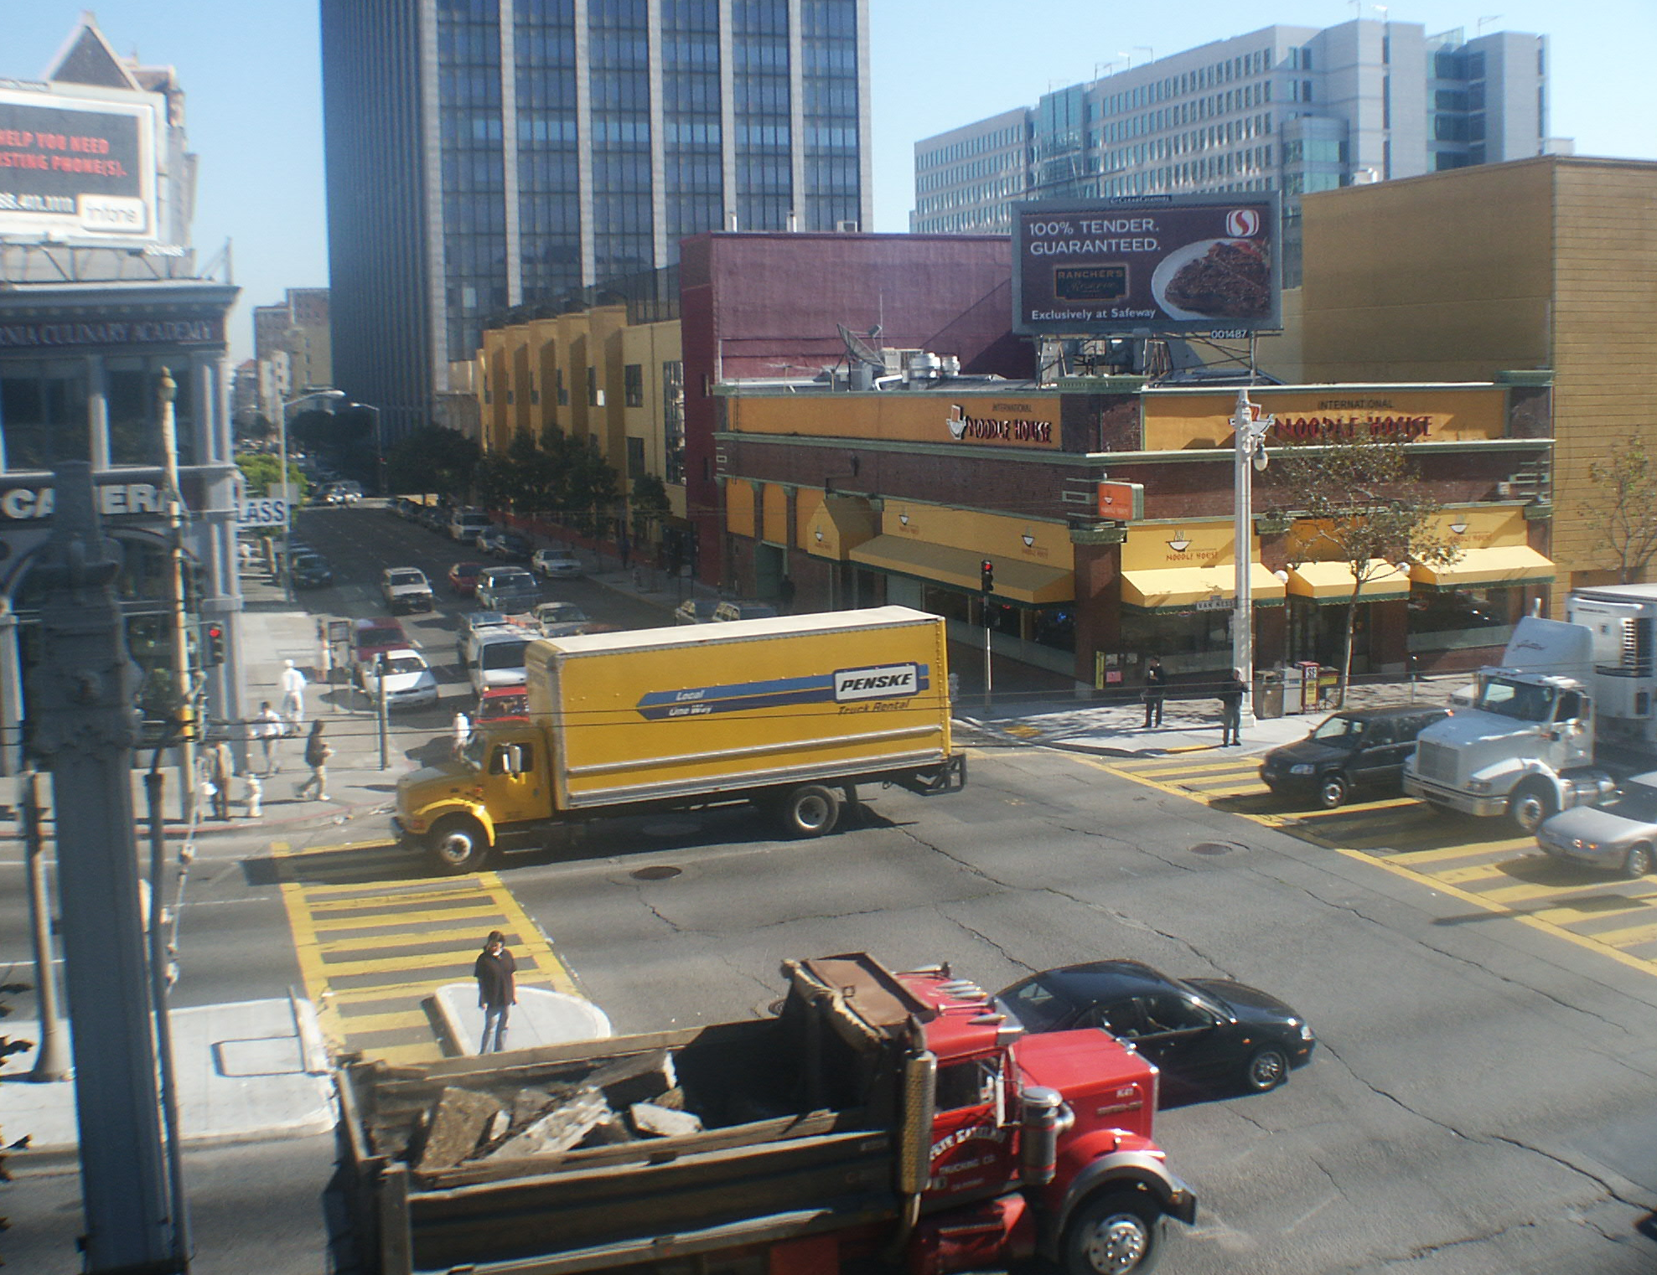

(Photo: Intersection of Van Ness and Turk, from perspective of the northwest corner of Turk, looking in an easterly direction.)
C. The Big Rig

The tractor portion of the rig that killed John Doe was a 1994 Peterbilt truck being driven by Roe Driver. Roe Driver bought the tractor in 1999.

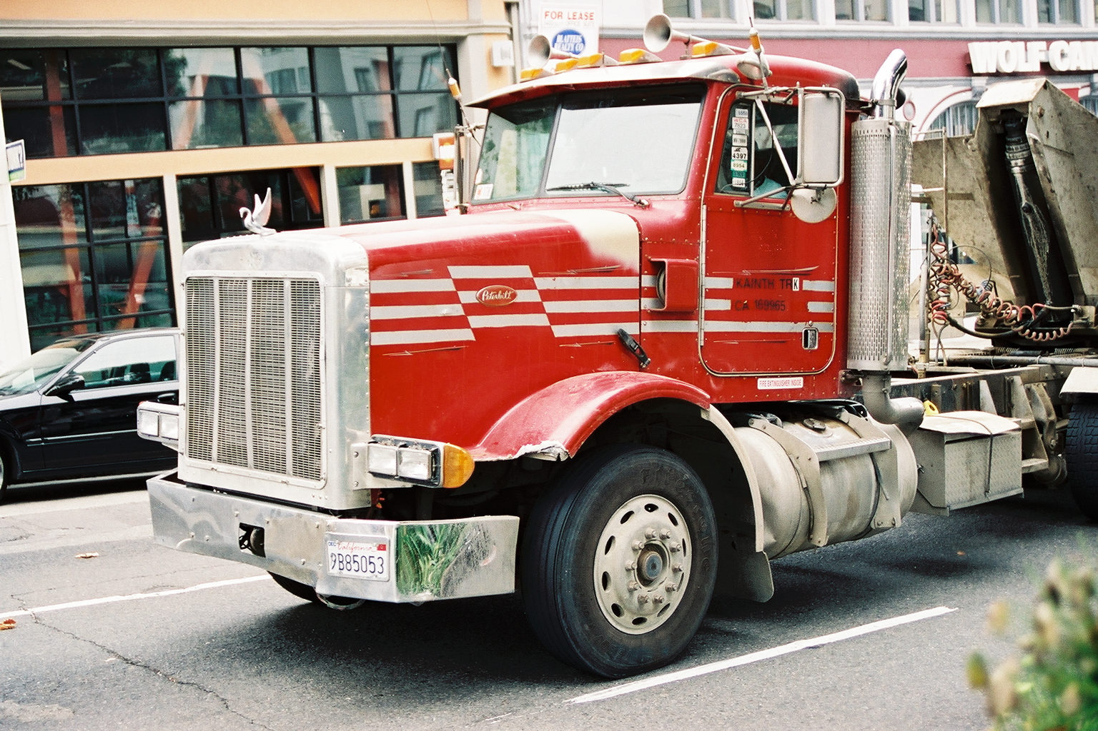

On the day of the accident, pursuant to Roe Defendant and Ram’s subcontractors agreement, Roe Defendant authorized Roe Driver to hook Roe Defendant’s 1994 open-hopper Peterbilt trailer to Roe Driver’s tractor. The combination, when fully loaded, weighed over +75,000 pounds and was 53 feet long.

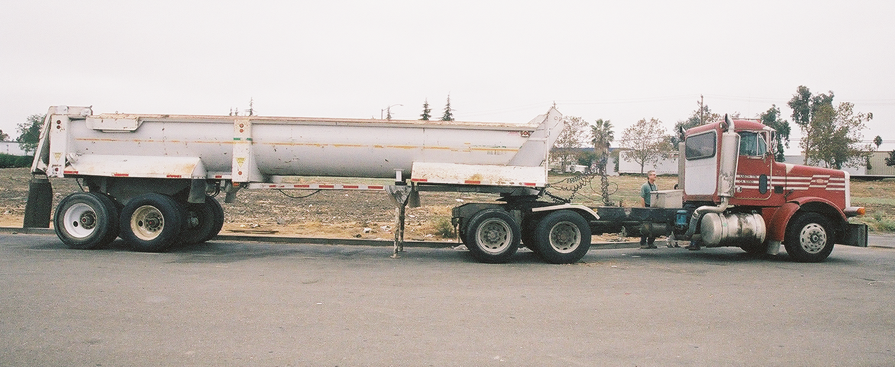

D. Operating Characteristics of The Big Rig

Big rigs, such as the subject tractor-trailer, experience “low speed tracking” when making turns. Low speed tracking is a well known phenomenon in the trucking industry and Roe Driver was very familiar with it and his truck’s propensity to off track. (Deposition of Roe Driver, Exhibit 4, 91:2-24.).

The physics of low speed tracking are simple: When a two-axle, four-wheel vehicle with the front wheels turned, travels a circular path at a hypothetical zero speed all wheels travel around the same turn center with zero slip angle. Put another way, the rear wheels track the same path the front wheels travel. However, when the same vehicle makes a slow, steady turn, the wheels on the rear axle of the vehicle do not track the same path of travel as the front wheels. Instead, the rear wheels track inside the circular paths of the front wheels. This effect is more pronounced when semi trailers and/or trailers are attached. The difference in the path radii followed by the rear wheels versus the front wheels is called the “off tracking dimension.”

The phenomenon of low speed tracking creates a hazard with a risk of serious injury or death to pedestrians standing at or near a corner or within a marked cross walk over which a big rig will travel in making a right hand turn. When a big rig makes a right hand turn at a corner, its trailer wheels will track closer to the curb than its tractor wheels. This results in the potential of the trailer portion of the big rig striking a pedestrian standing at or near the corner or stepping into or walking in a marked crosswalk across which the big rig will travel in making its right hand turn. Finally, it also results in the potential that a pedestrian walking within a marked cross walk can become trapped between the cab and being struck.

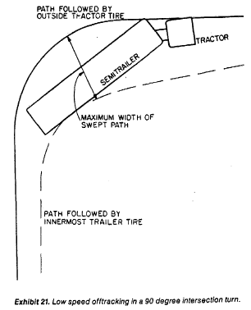

Statistically, the most typical kind of accidents involving the offtracking phenomenon occur in areas where pedestrians are standing near the roadway edge or in a cross walk and are struck by the rear wheels of a turning, single-unit vehicle or tractor-trailer. In light of all of the foregoing, a big rig truck driver must pay particular attention to the presence of pedestrians at corners or inside the cross walks at intersections where a big rig is making a right hand turn.

Plaintiffs’ experts will testify that the offtracking dimension of the subject tractor-trailer combination was particularly severe, which further enhanced the hazard involved in the rig negotiating a right hand turn at an intersection where many pedestrians traveled during peak hours.

E. The Accident
On the morning of the accident, John Doe kissed his wife goodbye, left his home in Oakland, and crossed the Bay on BART to San Francisco. That same morning, defendant Roe Driver, driving his own truck and hauling the trailer belonging to defendant Roe Defendant, began a trip to downtown San Francisco from the Ryan landfill in Brisbane. The trailer was loaded. Roe Driver was operating his vehicle pursuant to a subhauling agreement with Roe Defendant.

When John Doe arrived in San Francisco, he debarked from the train and began the ten to fifteen minute walk to his place of employment. As John Doe was approaching the corner of Van Ness and Turk, Roe Driver was driving his rig, westbound on Turk, past the Tenderloin Community School where students were arriving, to the corner of Turk and Van Ness. An eye witness reports that at that time the big rig was approaching the intersection, John Doe was standing on the northeast corner of Van Ness and Turk. (Exhibit 5, Deposition of Witness, p. 58:17-60:20 and Ex. 1 thereto.) It was approximately 8:15 a.m. when Roe Driver arrived at the intersection, where he testified he stopped for the red light controlling traffic on Turk.. Thus, had Roe Driver been looking, he would have seen John Doe, who was clearly visible, standing on the corner waiting to cross Van Ness.

The light controlling westbound traffic on Turk Street turned green and the pedestrian signal controlling pedestrian travel across Van Ness indicated pedestrians could cross Van Ness. At this point, an eye witness observed John Doe step off the curb, with the right of way and begin to cross Van Ness in the crosswalk. (Exhibit 5, Deposition of Witness, p. 49:12-20.) Roe Driver turned onto Van Ness, swinging wide into the #2 lane with his cab in order to compensate for the narrower turning radius of the trailer wheels caused by the low speed off tracking phenomenon discussed above. In so doing, the tractor (cab) crossed in front of John Doe’s path of travel and cut him off in the cross walk while the following trailer offtracked, striking John Doe, knocking him to the pavement, and running over and crushing him with the right rear tires on the trailer’s passenger side. Roe Driver confirmed in deposition that he too believed the right rear tires on the trailer’s passenger side struck John Doe. (Exhibit 4, Deposition of Roe Driver, p. 199:16-19, Ex. 3-F.)

Plaintiffs’ experts will opine that a truck driver approaching an intersection should look out for pedestrians and that before turning through an intersection, a truck driver must ascertain whether pedestrians are nearby and attempting to cross the street or are stepping into or walking in the intersection through which the truck will pass.

Plaintiffs’ experts will further testify that as a truck driver executes a turn, the truck driver must be checking his mirrors and looking out of his windows to ensure that the intersection is clear of pedestrians. According to plaintiffs’ human factors expert, a truck driving complying with the foregoing would have had no problem seeing the corner all the way through his turn and should have been looking in his mirrors throughout the course of the turn; if he had done so, he would have been able to see John Doe.

From all of the available evidence, physical and testamentary, it is clear that Roe Driver failed to take these actions. While Roe Driver contends he was looking his rear view mirrors as he made his turn, he also testified he did not see John Doe at any time, even though eyewitnesses place John Doe standing at the corner as the truck was approaching the intersection and place John Doe stepping off the curb and into the marked intersection with the green light before the truck driver began executing his turn. Thus, the direct and circumstantial evidence does not support Roe Driver’s position. First, John Doe was fully visible to anyone looking. Second, Roe Driver admits that he did not see John Doe at any time and that he had no idea an accident had occurred and did not stop until he heard bystanders yelling for him to stop.

The San Francisco Fire Department was dispatched to the scene, and they transported John Doe to San Francisco General Hospital, where trauma surgeons tried to repair the damage caused by the accident. John Doe had multiple blunt force injuries, including multiple skin abrasions, multiple pubic bone fractures, traumatic amputation of his prostate and rectum, avulsion and degloving injuries to the anterior abdominal walls and spermatic cords, massive avulsed degloved skin and subcutaneous tissue at his lower back, buttocks, and upper and lower legs, and bilateral tibia and fibula fractures.

A social worker phoned Jane to tell her that her husband had been in an accident and that he was at the hospital. Jane gathered the children from school and drove to the hospital, where she was informed of the extent of her husband’s injuries. Approximately one hour later, she was informed that the damage was too extensive—her husband was dead.

Legal Analysis

Liability of Defendant Roe Driver
John Doe is dead, and the Doe family shattered because of Roe Driver’s negligence. The jury will be instructed at trial as follows:

A person must use reasonable care in driving a vehicle. Drivers must keep a lookout for pedestrians, obstacles, and other vehicles. They must also control the speed and movement of their vehicles. The failure to use reasonable care in driving a vehicle is negligence.
A driver must use reasonable care when turning.
The duty to use reasonable care does not require the same amount of caution from drivers and pedestrians. While both drivers and pedestrians must be aware that motor vehicles can cause serious injuries, drivers must use more care than pedestrians.
(CACI Nos. 700, 705, and 707, emphasis added.)

The evidence will show that Roe Driver failed to use reasonable care in operating his tractor-trailer in a busy intersection during the morning rush hour. Witnesses have testified and will testify at trial that multiple pedestrians were in the vicinity of the accident site and that John Doe was standing on the corner of Van Ness and Turk waiting to cross Van Ness as Roe Driver was approaching the intersection.

Moments before the accident a pedestrian had crossed the marked pedestrian crosswalk on Turk, fully in view of Roe Driver, who was on Turk, nearly at its intersection with Van Ness. Yet Roe Driver testified that he did not see the pedestrian and he did not see John Doe, even though both were plainly visible to anyone paying attention to foot traffic. (Exhibit 4, Deposition of Roe Driver, pp. 95:2-25; 111:6-19.)

Plaintiffs’ experts will opine that Roe Driver had good visibility at the time of the accident; that multiple pedestrians were in the vicinity at the time of the accident; that Roe Driver should have been looking out for pedestrian traffic as he made the right-hand turn onto Van Ness; that Roe Driver should have been checking his mirrors which were, in fact, poorly adjusted; and that had Roe Driver looked, he would have seen John Doe in the crosswalk and could have avoided striking and killing him simply by waiting for John Doe to clear the northeast side of the cross walk before turning on to Van Ness. Further, one eyewitness to the accident has testified that Roe Driver “whipped” around the corner and was traveling at a higher rate of speed than she normally observes in this particular intersection. (Exhibit 5, Deposition of Witness, pp. 26:16-23, 51:3-9.) The jury will have no difficulty in concluding that John Doe’s death was a result of Roe Driver’s negligence and inattentiveness.

Liability of Defendant Roe Defendant
Defendant Roe Defendant is vicariously liable for Roe Driver’s negligence. Restatement Torts section 428 provides:
An individual or a corporation carrying on an activity which can be lawfully carried on only under a franchise granted by public authority and which involves an unreasonable risk of harm to others, is subject to liability for physical harm caused to such others by the negligence of a contractor employed to do work in carrying on the activity.
The seminal California case on this issue is Taylor v. Oakland Scavenger Co. (1941) 17 Cal.2d 594. In Taylor, a garbage truck struck a high school student on the school’s premises. The student sued the truck's driver, the truck’s owner, and Oakland Scavenger Company, a garbage collector working under a contract with the City of Oakland. On Oakland Scavenger’s appeal following a verdict in favor of the plaintiff, Oakland Scavenger claimed it was not liable for the driver’s negligence because the truck's owner was an independent contractor over whom Oakland Scavenger exercised little supervision or control. (Id. at p. 603.) The Supreme Court disagreed:
An employer is generally liable for negligent acts of an employee performed within the scope of employment, but if an independent contractor rather than master and servant relationship exists, the independent contractor usually is alone liable for his negligent acts. If, however, an individual or corporation undertakes to carry on an activity involving possible danger to the public under a license or franchise granted by public authority subject to certain obligations or liabilities imposed by the public authority, these liabilities may not be evaded by delegating performance to an independent contractor. The original contractor remains subject to liability for harm caused by the negligence of the independent contractor employed to do the work.
(Id. at p. 604 (emphasis added).)

The rule articulated in Taylor was reaffirmed by the Supreme Court in Eli v. Murphy (1952) 39 Cal.2d 598. In Eli, the plaintiffs were injured when their car was struck by a tractor and semitrailer driven and owned by the Murphys and used to transport freight under a contract between the Murphys and C.M.T., a highway common carrier licensed by the California Public Utilities Commission (PUC). (Id. at p. 598.) On C.M.T.’s appeal following a verdict in favor of the plaintiffs, the Supreme Court agreed with the plaintiffs that “under both the common law and certain regulations of the [PUC], C.M.T., as a highway common carrier, could not delegate its duties to an independent contractor so as to escape liability for their negligent performance.” (Id. at p. 599.)

The common law principle upon which plaintiffs rely has been enunciated in section 428 of the Restatement of Torts, and has frequently been applied to impose liability upon franchised common carriers who have engaged independent contractors to transport goods over the public highways. [Citations.] We have concluded that it is applicable here. [¶] C.M.T., operating as a highway common carrier, is engaged in a “business attended with very considerable risk” [citations], and the Legislature has subjected it and similar carriers to the full regulatory power of the [PUC] to protect the safety of the general public. [Citations.] The effectiveness of safety regulations is necessarily impaired if a carrier conducts its business by engaging independent contractors over whom it exercises no control. If by the same device it could escape liability for the negligent conduct of its contractors, not only would the incentive for careful supervision of its business be reduced, but members of the public who are injured would be deprived of the financial responsibility of those who had been granted the privilege of conducting their business over the public highways. Accordingly, both to protect the public from financially irresponsible contractors, and to strengthen safety regulations, it is necessary to treat the carrier’s duties as nondelegable. [Citations.] [¶] ...
The Legislature has ... classified highway common carriers such as C.M.T. apart from others, and by so doing has indicated special concern with the safety of their operations.... [¶] ... [¶] In view of the more extensive and regular operations of highway common carriers as compared with others, the Legislature could reasonably conclude that the safety of their operations is of special importance and legislate accordingly. Highway common carriers may not, therefore, insulate themselves from liability for negligence occurring in the conduct of their business by engaging independent contractors to transport freight for them.
(Id. at pp. 599- 601 (fn. omitted).)

In Snyder v. Southern Cal. Edison Co.(1955) 44 Cal.2d 793, the Supreme Court quoted at length from Eli, then expanded the nondelegable duty rule this way:

Where an activity involving possible danger to the public is carried on under public franchise or authority[,] the one engaging in the activity may not delegate to an independent contractor the duties or liabilities imposed on him by the public authority [citations] and generally speaking there are many situations in which the person cannot absolve himself from liability by delegating his duties to an independent contractor. [Citations.]
(Id. at pp. 798-799 (emphasis added).)

In Klein v. Leatherman (1969) 270 Cal.App.2d 792, where the subhauler’s permit had been revoked and he was operating without the required public liability insurance, the Court of Appeal noted that Snyder spoke in terms of an activity carried on under a public “franchise or authority.” (Id. at p. 795 (empasis in original).) The Court of Appeal then held that, in

consonance with the trend of such decisions, the facts and public policy involved in this case require us to hold that the duties of care of [the defendant Leatherman, as a] common carrier [operating with a permit] and as a contract carrier [citation] were nondelegable; and that he is chargeable with the negligence of [his subhauler] and its driver.... At the time of [the plaintiff’s] injury ..., [the subhauler] had forfeited its legal permission to operate on the highways. Therefore, its performance can only be legalized by inferring [the subhauler] was an agent of Leatherman, operating under his permit. [Citations.] A highway contract carrier engaging another as a subhauler thus is under a practical compulsion to verify that the subhauler possesses an unrevoked permit and the required insurance coverage. This is in the public interest, as well as his own.
(Id. at p. 796.)

In Gamboa v. Conti Trucking, Inc. (1993) 19 Cal.App.4th 663, a wrongful death action, Roberto Gamboa was killed when his bicycle was struck by a tractor-trailer owned by Alberg Trucking and driven by its employee. At the time of the accident, Alberg Trucking (an independent contractor) was subhauling freight for Conti Trucking. Both Alberg and Conti were licensed by the PUC as highway carriers, and Conti had verified that Alberg had the appropriate amount of liability insurance. Conti Trucking successfully moved for summary judgment. The Court of Appeal reversed stating in pertinent part:

Conti Trucking contends that to the extent of any nondelegable duty imposed by Eli v. Murphy, Conti Trucking’s vicarious liability was extinguished pursuant to Klein v. Leatherman. ... [¶] ... [¶] ... Conti Trucking contends that if the primary carrier meets its obligation to ensure that the independent contractor carrier is licensed to haul freight on California highways and has the required amount of liability insurance, it has satisfied its nondelegable duty under Eli v. Murphy and any vicarious liability is extinguished.
... The holding of Klein v. Leatherman ... is an expansion of the nondelegable duty doctrine. The Court of Appeal recognized that one truck on the highway tends to be like any other and “[i]t is difficult to discern wherein classification of the operation on the highway as a privilege under franchise, or as a right under a permit, changes the degree of protection required.” [Citation.] Klein v. Leatherman appears to be the first and only reported opinion in California applying the rule of section 428 of the Restatement of Torts to a nonfranchised highway contract carrier.
[Klein v. Leatherman ] ... states that the ‘... monetary liability under the nondelegable duty may be eliminated, or diminished, pro tanto.’ [Citation.] This, of course, would follow since any amount a plaintiff may recover from a vicariously liable highway common carrier would be reduced by any payment made by or on behalf of the primary tortfeasor and eliminated completely if the insurance coverage is sufficient to cover the damages sustained. Any amount paid by one joint tortfeasor operates to reduce pro tanto the amount of damages that a plaintiff may recover against other joint tortfeasors. [Citations.] However, the nondelegable duty of care would not be affected.
(Gamboa v. Conti Trucking, Inc., supra, 19 Cal.App.4th at pp. 666-668.)

Finally, in Serna v. Pettey Leach Trucking, Inc. (2003) 110 Cal.App.4th 1475, the Court of Appeal held that section 428 applied in a case where a motorcyclist was killed in a collision with a tractor-trailer being operated pursuant to a subhauling agreement, so as to render the owner of the vehicle vicariously liable for the negligence of the driver. After reviewing the cases discussed above, the Court of Appeal stated the applicable rule with respect to nondelegable duties of trucking companies who retain independent contractors pursuant to a subhauler agreement:
Hence, the rule is that a carrier who undertakes an activity (1) which can be lawfully carried on only under a public franchise or authority and (2) which involves possible danger to the public is liable to a third person for harm caused by the negligence of the carrier’s independent contractor. [Citations.] Were the rule otherwise, a carrier could escape liability for the negligence of its independent contractors, thus reducing the incentive for careful supervision and depriving those who are injured of the financial responsibility of those to whom the privilege was granted. For these reasons, the carrier’s duties are nondelegable, and it is only when the carrier is “not regulated” at all that the rule is otherwise. [Citations.]
(Id. at pp. 843-844.)

Here, Roe Defendant meets both prongs of this test. First, Roe Defendant was engaged in an activity which can be lawfully carried on only under a public franchise or authority. Roe Defendant has operated its business from the day of its incorporation in 1999 to the present under Motor Vehicle Permits issued by first, the Public Utilities Commission, and later, by the Department of Motor Vehicles. (Exhibit 7, Motor Carrier Permit; Exhibit 8, Deposition of Roe Defendant President, pp. 44:5-17, 79:4-17, 80:12-81:6.) These permits show that Roe Defendant is a motor carrier of property for hire as defined by Vehicle Code section 34601. Further, Roe Defendant is subject to and has complied with the BIT Program managed by the California Highway Patrol. (Exhibit 8, Deposition of Roe Defendant President, pp. 35:18-36:7, 79:25-80:4.)

Roe Defendant also meets the second prong of the test, in that it is and has been engaged in an activity which involves possible danger to the public. First, the fact that the operation of heavy trucks on public highways is inherently dangerous has been recognized repeatedly by the courts of this state. (Serna v. Pettey Leach Trucking, Inc., supra, 110 Cal.App.4th at p. 1481, citing Eli v. Murphy, supra, 39 Cal.2d at p. 599.) Second, the president of Roe Defendant and the corporation’s designated representative, admitted at her deposition that “these trucks, whether they’re operated by an employee or a subhauler, have the potential to cause serious injury or death if somebody is not careful.” (Exhibit 8, Deposition of Roe Defendant President, p. 84:8-13.)
Thus, Roe Defendant’s freight hauling business was regulated by the State of California. Roe Defendant Trucking’s business constituted an activity which, if negligently performed, could lead to serious injury or death. That is exactly what happened in this case. Roe Defendant Trucking is vicariously liable for the negligence of its subhauler Roe Driver.
C. Alleged Comparative Negligence on Part of John Doe
Defendants’ only potential defense is to claim that John Doe blindly ran out into the crosswalk and into the truck. Defendants basis for this preposterous claim is the uncorroborated testimony of witness Bob Isaw, who admits that “his mind works very strange” and that the day of the accident was “a strange day.” ((Exhibit 9, Isaw Deposition, p. 49:20-22.) According to Isaw, he saw John Doe run into the cross walk as Roe Driver was making his turn and consequently assumed, although he could not see, that John Doe ran into the side of the trailer of the big rig.
Defendant’s theory fails for two reasons. First, John Doe’s injuries are inconsistent with his having run into or under the truck. Second, Isaw was not in a position to observe that which he contends he saw.
While no one, including driver Roe Driver, actually observed the collision between the truck and John Doe, it is undisputed that John Doe sustained no injuries above his pelvic area. Plaintiffs’ experts will testify that in light of the nature of John Doe’s injuries, it is most probable that after the tractor had passed John Doe, the following inboard-tracking trailer struck him, knocking him to the pavement followed by the wheels of the Roe Defendant trailer running over his lower torso and legs. The nature and location of John Doe’s injuries are wholly inconsistent with any suggestion that John Doe fell after running into or under the trailer; rather, all of the physical evidence demonstrates that John Doe’s upper body was outboard of the wheels.

Isaw’s testimony that John Doe ran into the intersection and hit the truck is not persuasive. Isaw was standing on the west side of south bound Van Ness, several hundred feet north of the intersection of Van Ness and Turk. North and southbound traffic on Van Ness is separated by a median strip with bushes and trees. Further, traffic is always heavy during morning rush hours on Van Ness and the day of the accident was no exception.
Isaw testified that he happened to look in the direction of the north east side of the intersection because he noticed an “extremely lovely young lady” on the east side of north bound Van Ness who looked like Marlene Dietrich “smoking a cigarette and enjoying that cigarette.” Isaw had a bad cigarette habit and couldn’t afford cigarettes. When he saw the young woman, who was both attractive and smoking, he recalls thinking “I was wishing I was that cigarette.” (Ex. 9, Isaw Deposition, p. 17:19-18:10.) It was under these circumstances that Isaw recalls seeing John Doe come out from the Turk side of Fox Camera building and it looked to him like John Doe was running because of the way John Doe’s briefcase was swinging as he moved. Isaw admits that he only saw John Doe for a total of about 1 ½ seconds. (Exhibit 9, Isaw Deposition, p. 48:15-21.)
Plaintiffs’ experts will testify that Isaw’s line of sight was obstructed by north and south bound traffic on Van Ness as well as the tree- and bush-lined median strip separating north and southbound traffic on Van Ness. Isaw admits that he never saw John Doe struck by the truck as his view was obstructed by the turning big rig.
D. Jury Pool Experience With Vehicle/Pedestrian Accidents In San Francisco.
The venue in which this case is pending must also be considered in evaluating defendants exposure to judgment and whether John Doe is comparatively negligent. San Franciscans are an urban population that, because of their common experience as pedestrians and users of mass transit, have personal knowledge of the perils facing pedestrians in the city. A recent study conducted by the National Highway Traffic Safety Administration and reported extensively in the media found that San Francisco is the fourth most dangerous city in the country for pedestrians. (Exhibit 6.) Further, most members of the jury can be expected to be intimately familiar with the perils faced by pedestrians in San Francisco, because they have faced them themselves. A jury pool informed by the media and their own experience and knowledge can be expected to identify with John Doe, be very sympathetic to his plight as a pedestrian, and more likely than not will find Roe Driver liable for a death caused by his negligence.

Based on the foregoing, we believe it is highly unlikely that a jury in this venue will allocate a significant degree of fault to John Doe. Nevertheless, for purposes of settlement discussions, and in order to present a conservative evaluation of defendants’ exposure, plaintiffs have assumed that a jury may find upwards of 10% comparative negligence on the part of John Doe, and have entered this percentage into the Exposure Table below.

Damages
The jury will be instructed at trial as follows:
If you decide that plaintiffs Doe have proved their claim against defendants Roe Driver and Roe Defendant for the death of John Doe, you also must decide how much money will reasonably compensate the Does for the death of John Doe. This compensation is called “damages.”
The Does do not have to prove the exact amount of these damages. However, you must not speculate or guess in awarding damages.
The damages claimed by the Does fall into two categories called economic damages and noneconomic damages. You will be asked to state the two categories of damages separately on the verdict form.
The Does claim the following economic damages:
1. The financial support, if any, that John Doe would have contributed to the family during the life expectancy of John Doe;
2. The loss of gifts or benefits that the Does would have expected to receive from John Doe;
3. Funeral and burial expenses; and
4. The amount paid, and reasonably certain to be paid in the future, to obtain household services that John Doe would have provided.
Your award of any future economic damages must be reduced to present cash value.
Jane Doe also claims the following noneconomic damages:
1. The loss of John Doe’s love, companionship, comfort, care, assistance, protection, affection, society, moral support; and
2. The loss of the enjoyment of sexual relations.
The Doe childrene also claim the following noneconomic damages:
1. The loss of John Doe’s love, companionship, comfort, care, assistance, protection, affection, society, moral support; and
2. The loss of John Doe’s training and guidance.
No fixed standard exists for deciding the amount of noneconomic damages. You must use your judgment to decide a reasonable amount based on the evidence and your common sense. Your award for noneconomic damages should not be reduced to present cash value.
(CACI No. 3921.)

Economic Damages
Plaintiffs have retained a forensic economist in this case. He was asked to prepare an economic loss analysis for past wage loss, future loss of earning capacity and loss of household services. The sconomist’s analysis is based on the following assumptions:

(a) John Doe was earning $17 per hour at the time of the accident.
(b) John Doe’s employer was paying a total of $819.50 per month for health insurance, consisting of $670.70 per month for medical insurance and $148.89 per month for dental insurance. The health plan is an age-based plan, and the premium paid for John Doe would have increased over time.
(c) After three years as a paralegal, John Doe would have been earning $24.76 (2002 dollars) per hour. (Report of plaintiff’s vocational rehabilitation expert, Exhibit 10.)
(d) John Doe could have entered law school (Golden Gate University) in August 2002 and graduated June 2006, reviewed for and taken the bar in July 2006, and began practicing in January 2007. If he had followed this plan, the total cost of this education would have been $76,232. (Report of plaintiff’s vocational rehabilitation expert, Exhibit 10.)
(e) The average starting salary for a San Francisco attorney is $76,523, increasing to $121,014 after three years. The average starting salary for a Alameda County attorney is $66,602, increasing to $97,323 after three years. (Report of plaintiff’s vocational rehabilitation expert, Exhibit 10.)
(f) Had he not been killed, John Doe would have continued to contribute household services to the family.
Based on the foregoing, plaintiffs’ counsel requested that the economist analyze the economic damages (past wage loss, future loss of earning capacity and loss of household services suffered by the Doe family in the context of three alternative employment scenarios:
1. John Doe continues working as paralegal to age 70.
2 John Doe continues working as paralegal, attends Golden Gate at night, becomes a San Francisco attorney in January 2007, then works to age 70.
3. John Doe continues working as paralegal, attends Golden Gate at night, becomes an Alameda attorney in January 2007, then works to age 70.

Under each of the above scenarios, John Doe would have continued to contribute household services.

The economist calculated the present cash value of the Doe family’s economic loss using generally accepted statistical techniques and econometric methods of analysis.

Past wage loss and loss of household services, reduced to present value and adjusted for John Doe’s personal consumption is $110,155. That sum remains a constant regardless of which of the three employment alternatives the jury determines would have occurred, had John Doe not been killed. Past wage loss and loss of household services are included in the total loss figures expressed below.

For Alternative 1 (Paralegal), the economist determined that as of December 1, 2003, the family has lost and will suffer in the future a total loss of $961,063 because of John Doe’s death (reduced to present value and adjusted for John Doe’s personal consumption); for Alternative 2 (Paralegal, then San Francisco Attorney), $1,404,664; for Alternative 3 (Paralegal, then Alameda Attorney), $1,233,756. (Economic Impact Report, Exhibit 11.)

For purposes of mediation, this settlement discussion assumes the conservative mid range total economic loss alternative of $1,233,756.

In addition to the economic losses discussed above, plaintiffs expended approximately $15,000 in funeral and burial costs. This amount has also been entered into the Exposure Table below.

Noneconomic Damages
As with any case, the precise amount of general damages is always open to conjecture. However, the amount of general damages awarded is to some extent dependent on the following circumstances:
1. The sympathetic or non-sympathetic nature of the victim;
2. The status of the defendant and the degree of culpability and financial responsibility to which the defendant is susceptible;
3. The seriousness of the event giving rise to the injury;
4. The nature of the injury itself; and
5. The nature and extent of special damages.
On the one hand, we have the Doe family. Through this brief, and the accompanying video, you have been provided with an opportunity to get to know the Does and their life. I think you will agree that the Does will present as a tremendously sympathetic and close-knit family who lost a husband, father, and friend.
Jane describes life as surreal and strange without John Doe. She has lost the capacity to organize herself. It is extremely difficult for her to focus: “I feel like I have ‘Adult Attention Deficit Disorder.’” She loses things more frequently. She procrastinates a lot, which she never did before John Doe’s death. Even simple tasks like grocery shopping are very difficult for her. She says they eat out a lot because she hasn’t made it to the store. She says it is very difficult for her to multi-task and meet deadlines.
For the kids, everything is hard. The son’s personality is less outgoing than his sister’s, which makes it even harder for him to deal with his father’s death. He doesn’t discuss his feelings easily except to say that he misses his dad. While he scored his first soccer goal recently and was very excited about it he was also very sad that his dad was not there to see it. Because of the son’s ongoing emotional problems, Jane arranged for him to see a psychologist. During his first visit, in which Jane was included, he talked a lot about his father and for the first time revealed that he believes his father had been killed by terrorists. Clearly, this young child is suffering severe and permanent emotional problems as a result of the death of his father. Conversely, the daughter is much more outgoing and immerses herself in teen activities. She doesn’t like to be reminded of the incident or to talk about John Doe’s death. Jane says it is hard to know what will happen to her daughter since she has lost her father image.
In the face of the information about the Doe’s tragedy, we have defendant Roe Driver, a professional truck driver who knew he was operating a vehicle capable of maiming and killing and who, in a moment of inattentiveness, destroyed the Does’ life as they knew it.
This settlement discussion assumes general damages of $3,746,301, which is three times the total of special damages. That ratio is conservative given the magnitude of the Does’ loss, the sympathetic nature of the family, and the venue in which the case is pending.

VI. Exposure

Economic Damages- Past Wage Loss as of 12/1/03 | $ 112,998
Economic Damages-Present Value of Future Loss of Earning Capacity as of 12/1/03 | $1,238,076
Loss of Household Services-Past and Future | $ 211,500
Reduction for Personal Consumption | <$328,818>
Funeral and Burial Costs | $ 15,000
Total Economic Damages | $1,248,756
Noneconomic Damages (3 X multiplier of economic loss) | $3,746,301
Gross Exposure | $4,995,068
Less Estimated 10% Decedent’s Negligence | <$499,506>
TOTAL EXPOSURE | $4,495,562

VII. Demand

The “Total Exposure” figure is a conservative estimate of the dollar amount to which defendants are exposed should this case proceed to trial. However, plaintiffs are aware of the unfortunate low insurance policy limits totaling $1,750,000 and have no desire to invade any personal assets of defendants Ram and Roe Defendant. For that reason, plaintiffs are willing, at this time, to accept the total $1,750,000 policy limits as complete resolution of this matter.
A Code of Civil Procedure section 998 offer reflecting this demand is being served contemporaneously with this mediation brief on defendants. Upon expiration of the 998 offer, the insurance policy limits will be viewed as a floor, not a ceiling, for any subsequent attempts to resolve this matter before trial. The offer to settle for policy limits will not be renewed once the time to accept it has passed.
Duplicate copies of the settlement package are provided so that defendants’ insurance carriers will have ample time and adequate information to evaluate defendants exposure within the time period in which the Offer to Compromise is open.
VIII. Conclusion

The Does suffered a catastrophic and life-altering loss due to the negligence of defendant Roe Driver. Although it is remotely possible that defendants could obtain a defense verdict in this matter, it is more probable that judgment will be rendered against defendants for the final exposure figure, or more.
– • –

input.doc

I. Introduction 1

II. Parties 2

A. Plaintiffs Doe 2

B. Defendant Roe Driver 2

C. Defendant Roe Defendant 2

III. Facts 3

A. Background 3

B. The Accident Site ………………………………………………………………………...6

C. The Big Rig………………………………………………………………………………..7

D. Operating Characteristics of the Big………………………………………………………..8

E. The Accident………………………………………………………………………………9

IV. Legal Analysis 11

A. Liability of Defendant Roe Driver 11

B. Liability of Defendant Roe Defendant 12

C. Alleged Comparative Negligence of John Doe…………………….………………15

D. Jury Pool Experience With Vehicle/Pedestrian Accidents in San Francisco.………………16

V. Damages 17

A. Economic Damages 18

B. Noneconomic Damages 19

VI. Exposure………………………………………………………………………………… 21

VII. Demand…………………………………………………………………………………. 21

VIII. Conclusion……………………………………………………………………………… 22

For further discussion on the physics of off tracking see: Exhibit 3.
Although an eyewitness says she didn’t see him stop, but recalls seeing the truck whip around the corner. (Witness Deposition, p. 53:21-53:2.)
Roe Defendant Trucking Corporation has refused to stipulate that it owed a nondelegable duty to ensure its trailer was operated in a no negligent manner by its subhauler Roe Driver. Accordingly, plaintiffs’ have filed a Motion for Summary Adjudication on the issue of duty.
Isaw claims that he had a clear view of the intersection because he remembers that north and southbound Van Ness was closed off from traffic. However, photographs taken the day of the accident within minutes after the accident demonstrate north and south Van Ness was open and traffic was heavy.
Although inadmissible, the parties and the mediator should take “mediation notice” of the study and media reports based thereon because of their impact on the pool from which the jury will be drawn.

